IT Ticket Analysis Report

By Saketh Reddy

**Objective Questions**

1. **What is the total no. of attributes present in the data?**

Ans: 16

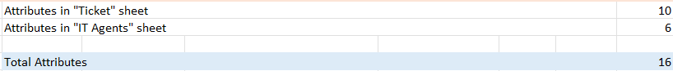

**Formula: =COUNTA**

1. **Which columns have inconsistent or missing values, and what is the count of such values?**

Ans: In the Tickets data there are some inconsistencies. They

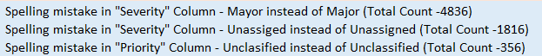



**Used “Find and Replace” feature, and corrected this**

1. **What is the average daily ticket volume over time?**

Ans: The average daily ticket volume over time is 53.37

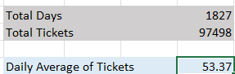



**Formula: =AVERAGE(C18:C1844)**

1. **What is the distribution of ticket categories (e.g., Login Access, System, Software)?**

Ans:

|  |  |
| --- | --- |
| **Request Category** | **Count of ID Ticket** |
| **Hardware** | 9.98% |
| **Login Access** | 29.94% |
| **Software** | 20.07% |
| **System** | 40.00% |

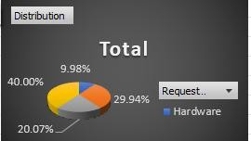

1. **How many tickets has each agent handled? Ans**

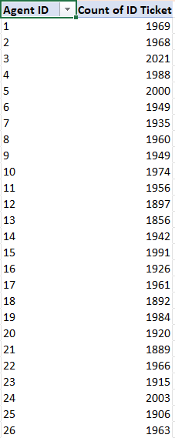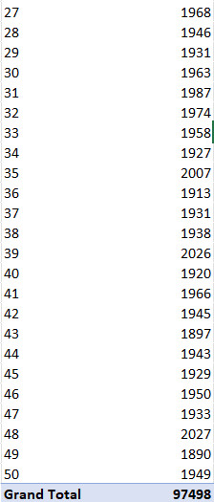

1. **How can you extract the domain from the email addresses in the IT Agents sheet?**

Ans: To extract the domain name from the email address by using right function, or text to column function.



**Formula:**

**=LEFT(MID(C1915,FIND("@",C1915)+1,LEN(C1915)),FIND(".",MID(C1915,FIND("@",C1915)+1,LEN(C1915)))-1)**

|  |  |  |
| --- | --- | --- |
| **Agent ID** | **`Email** | **Domain** |
| 1 | [lucero.mata@fp20analytics.com](mailto:lucero.mata@fp20analytics.com) | fp20analytics |
| 2 | [jesus.grajeda@fp20analytics.com](mailto:jesus.grajeda@fp20analytics.com) | fp20analytics |
| 3 | [elena.velez@fp20analytics.com](mailto:elena.velez@fp20analytics.com) | fp20analytics |
| 4 | [alberto.barraza@fp20analytics.com](mailto:alberto.barraza@fp20analytics.com) | fp20analytics |
| 5 | [willyberto.gonzales@fp20analytics.com](mailto:willyberto.gonzales@fp20analytics.com) | fp20analytics |
| 6 | [alberto.trejo@fp20analytics.com](mailto:alberto.trejo@fp20analytics.com) | fp20analytics |
| 7 | [estuardo.ocaño@fp20analytics.com](mailto:estuardo.ocaño@fp20analytics.com) | fp20analytics |
| 8 | [marisol.piedrahita@fp20analytics.com](mailto:marisol.piedrahita@fp20analytics.com) | fp20analytics |
| 9 | [jose.velasquez@fp20analytics.com](mailto:jose.velasquez@fp20analytics.com) | fp20analytics |
| 10 | [alberto.casillas@fp20analytics.com](mailto:alberto.casillas@fp20analytics.com) | fp20analytics |
| 11 | [lopez.moran@fp20analytics.com](mailto:lopez.moran@fp20analytics.com) | fp20analytics |
| 12 | [javier.davila@fp20analytics.com](mailto:javier.davila@fp20analytics.com) | fp20analytics |
| 13 | [griselda.galindo@fp20analytics.com](mailto:griselda.galindo@fp20analytics.com) | fp20analytics |
| 14 | [estuardo.torres@fp20analytics.com](mailto:estuardo.torres@fp20analytics.com) | fp20analytics |
| 15 | [guadalupe.galindo@fp20analytics.com](mailto:guadalupe.galindo@fp20analytics.com) | fp20analytics |
| 16 | [carlos.orci@fp20analytics.com](mailto:carlos.orci@fp20analytics.com) | fp20analytics |
| 17 | [lourdes.leon@fp20analytics.com](mailto:lourdes.leon@fp20analytics.com) | fp20analytics |
| 18 | [miller.gaviria@fp20analytics.com](mailto:miller.gaviria@fp20analytics.com) | fp20analytics |
| 19 | [alfonso.barraza@fp20analytics.com](mailto:alfonso.barraza@fp20analytics.com) | fp20analytics |
| 20 | [eduardo.luna@fp20analytics.com](mailto:eduardo.luna@fp20analytics.com) | fp20analytics |
| 21 | [alberto.gastelum@fp20analytics.com](mailto:alberto.gastelum@fp20analytics.com) | fp20analytics |
| 22 | [lorena.leon@fp20analytics.com](mailto:lorena.leon@fp20analytics.com) | fp20analytics |
| 23 | [guadalupe.hernandez@fp20analytics.com](mailto:guadalupe.hernandez@fp20analytics.com) | fp20analytics |
| 24 | [barbara.grijalva@fp20analytics.com](mailto:barbara.grijalva@fp20analytics.com) | fp20analytics |
| 25 | [sandra.lujan@fp20analytics.com](mailto:sandra.lujan@fp20analytics.com) | fp20analytics |
| 26 | [flores.sierra@fp20analytics.com](mailto:flores.sierra@fp20analytics.com) | fp20analytics |
| 27 | [isela.leyva@fp20analytics.com](mailto:isela.leyva@fp20analytics.com) | fp20analytics |
| 28 | [nurio.zepeda@fp20analytics.com](mailto:nurio.zepeda@fp20analytics.com) | fp20analytics |
| 29 | [segura.garcia@fp20analytics.com](mailto:segura.garcia@fp20analytics.com) | fp20analytics |
| 30 | [parra.luna@fp20analytics.com](mailto:parra.luna@fp20analytics.com) | fp20analytics |
| 31 | [guadalupe.torrico@fp20analytics.com](mailto:guadalupe.torrico@fp20analytics.com) | fp20analytics |
| 32 | [silvia.morales@fp20analytics.com](mailto:silvia.morales@fp20analytics.com) | fp20analytics |
| 33 | [guadalupe.villanueva@fp20analytics.com](mailto:guadalupe.villanueva@fp20analytics.com) | fp20analytics |
| 34 | [diana.rojo@fp20analytics.com](mailto:diana.rojo@fp20analytics.com) | fp20analytics |
| 35 | [melinda.barcelo@fp20analytics.com](mailto:melinda.barcelo@fp20analytics.com) | fp20analytics |
| 36 | [luis.torres@fp20analytics.com](mailto:luis.torres@fp20analytics.com) | fp20analytics |
| 37 | [jesus.pacheco@fp20analytics.com](mailto:jesus.pacheco@fp20analytics.com) | fp20analytics |

|  |  |  |
| --- | --- | --- |
| 38 | [enrique.montiel@fp20analytics.com](mailto:enrique.montiel@fp20analytics.com) | fp20analytics |
| 39 | [jesus.contreras@fp20analytics.com](mailto:jesus.contreras@fp20analytics.com) | fp20analytics |
| 40 | [alfredo.barreras@fp20analytics.com](mailto:alfredo.barreras@fp20analytics.com) | fp20analytics |
| 41 | [aldo.carrillo@fp20analytics.com](mailto:aldo.carrillo@fp20analytics.com) | fp20analytics |
| 42 | [darwin.echeverry@fp20analytics.com](mailto:darwin.echeverry@fp20analytics.com) | fp20analytics |
| 43 | [reyna.santacruz@fp20analytics.com](mailto:reyna.santacruz@fp20analytics.com) | fp20analytics |
| 44 | [eva.cardenas@fp20analytics.com](mailto:eva.cardenas@fp20analytics.com) | fp20analytics |
| 45 | [luis.arguello@fp20analytics.com](mailto:luis.arguello@fp20analytics.com) | fp20analytics |
| 46 | [rosa.olguin@fp20analytics.com](mailto:rosa.olguin@fp20analytics.com) | fp20analytics |
| 47 | [yomaira.agudelo@fp20analytics.com](mailto:yomaira.agudelo@fp20analytics.com) | fp20analytics |
| 48 | [aurelio.tanori@fp20analytics.com](mailto:aurelio.tanori@fp20analytics.com) | fp20analytics |
| 49 | [armando.sierra@fp20analytics.com](mailto:armando.sierra@fp20analytics.com) | fp20analytics |
| 50 | [ramon.macias@fp20analytics.com](mailto:ramon.macias@fp20analytics.com) | fp20analytics |

1. **How can you find the full name of an agent given their Agent ID?**

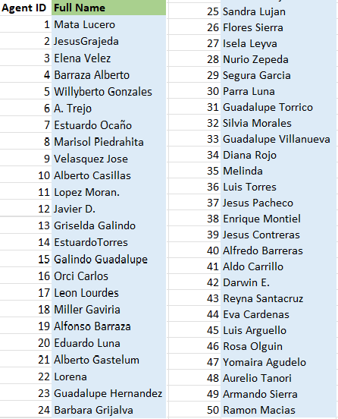Ans: We can find the full name of an agent by using VLOOKUP or Xlookup function.



**Formula: =VLOOKUP(I1915,'IT Agents'!A:B,2,0)**

1. **What is the count of each issue type (e.g., IT Error, IT Request)?**

Ans: The Count of each issue type can be calculated using the Count function

|  |  |
| --- | --- |
| **Issue type** | **Count of ID Ticket** |
| IT Error | 24278 |
| IT Request | 73220 |

1. **What is the daily average resolution time for tickets?**

Ans: Used pivot table to get the daily average resolution time and then used the below formula to calculate the average resolution time in days.



1. **How has the volume of tickets changed over time?**

Ans:

|  |  |
| --- | --- |
| **Row Labels** | **Count of ID Ticket** |
| 2016 | 13051 |
| 2017 | 14915 |
| 2018 | 18954 |
| 2019 | 21490 |
| 2020 | 29088 |



Total

35000

30000

25000

20000

15000

10000

5000

0

2016

2017

2018

2019

2020

1. **What is the average age of the IT agents?**

Ans: The average age of an IT agent is **39.46**



**Formula: =AVERAGE(IT_Agents[AGE])**

1. **Is there a correlation between the severity of issues and the resolution time?**

Ans: Very Weak Negative Correlation





**Formula: =CORREL(Tickets!K:K,Tickets!I:I)**

1. **How many categorical columns are there in the data? [Search about categorical and continuous data, and try to answer this question]**

Ans:

|  |
| --- |
| **Categorical vs. Continuous Columns in the Data** |
| **Categorical Data: Represents distinct groups or categories (e.g., Request Category, Severity).** |
| **Continuous Data: Represents measurable values with a range (e.g., Resolution Time, Year of Birth).** |
| **Tickets Sheet:** |
| **Categorical: 8 (ID Ticket, Employee ID, Agent ID, Request Category, Issue Type, Severity, Priority, Satisfaction Rate)** |
| **Continuous: 2 (Fecha, Resolution Time)** |
| **IT Agents Sheet:** |
| **Categorical: 4 (Agent ID, Full Name, Email, Month of Birth)** |
| **Continuous: 2 (Year of Birth, Day of Birth)** |